The little book of
Transformation

By Donna Durand

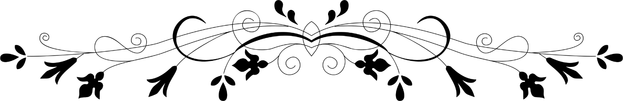

Ren Xue Water Valley Retreat, Alberta Canada
April 28 – May 4, 2018

Notes and poetry inspired by Yuan Tze talks, healing sessions and form practise. Many thanks to Melissa Kung for translation and fellow participants for exploring Big Love together with open minds and hearts.

Welcome home
Why are you here?
You must have come with a purpose.

Safety and effectiveness is of utmost importance for Ren Xue.
⋆
Healing
It is not that you concentrate on sickness. Think of healthy bright qi and bring this to any area of concern…
⋆
We need a theme:
Together let us walk hand in hand in order to achieve:
Learn together
Learn about ourselves
Work on the heart
⋆
Three keystones of Unified State:
1. Improve health
-3 qi disorders- flow of qi, quality of qi, and exchange of information (personal to universal)
-qi needs to be built up in the 3 Dantians: root, heart, head
2. Build the home of Shing-ling (heart consciousness)
-5 qualities of heart/home- trust, openness, love, gratitude, true respect. When these qualities are missing or underdeveloped, the opposite qualities may become dominant
FOCUS OF RETREAT IS BUILDING THE SHING-LING HOME

3. Uplifting life
-reaching a higher level of wisdom
⋆

Practice
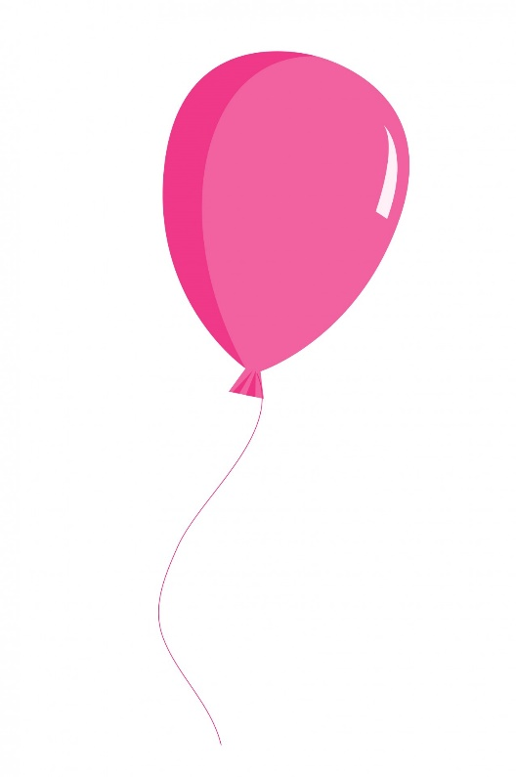
Breathe. Expand the abdomen as if it is a balloon.

Imagine you have a nose in your belly.
Breathing in …

breathing out…

Imagine this string is your flexible
spinal cord.
⋆

Clouds drifting in the sky

Circular flow of movement - a giant bird
Soaring spirals in the sky. Free and happy

The bird is moving as one. In light

⋆

Form
If nothing else
gather qi knead qi pull qi rub qi sit with qi
maintain calm, relaxed, natural state
gather qi- open- close- open- close
use the mind
close the eyes
draw the vision back
into the centre of the head
bring qi to the heart
maintain calm, relaxed natural state

⋆

Open to the universe with utmost reverence
⋆

Consciousness is the master of all. What is healthy consciousness? What is Shen? The higher mind.
Information is transmitted to a problematic area(health concern). The Shen consciousness is that there is 100% wellbeing. Personal consciousness has more influence on your qi than anyone or anything else.

⋆
Worry disturbs qi
Worry compounds and clusters
Worry consciousness
Can and will create
Something
Out of nothing

Unhealthy Patterns
We must both find and see our patterns and work on them. This is not the place to apply wishful thinking!

⋆

This day
Is good
This moment
Is good
This moment
Contains the universe

This universe
in constant flux
of shift and change
Gifts us with unique moments
breath wrapped parcels
filled with immense potential

begin
begin again
and again
begin

⋆

Jewels of the Heart

When the jewels of the heart
Lay dormant and dull
There is isolation and separation

When the jewels of the heart
No longer shine
The wellspring of health
And happiness
Dries up
⋆

The heart is a garden to tend. Shen is encouraged to grow here and supported so that it does not go dormant. This takes effort… or does it?

“ A pancake falls from the sky and hits you in the face! What luck!”
Yuan Tze shares a Chinese saying on enlightenment

⋆

Patterns of consciousness cannot be bypassed

⋆

TRUST

INDESPENSIBLE FOR ALL OF LIFE
WITHOUT TRUST THERE IS NO LIFE
⋆

Trust
Do you want to be trusted?
Can you be trusted?
Do you trust yourself?
Can I trust myself?

All forms of consciousness
rely on trust
Akin to air and sunshine
Water and food
Trust is a necessity

Without trust
Harm can be done

Trust
Do you want to be trusted?
Can you be trusted?
Do you trust yourself?
Can I trust myself?
⋆

Do I trust myself?
My eyes sting
Pressure comes-
A prickle up through the sinuses
For a split second
I cannot see

⋆

Special Abilities
Without trust, it is very difficult to manifest special abilities. The body has the ability to heal. Each cell has its own awareness.

With full trust, life changes. Do you know your life is near perfect? Full potential is given by the universe.

How we trust ourselves and how we trust others is the same thing.

The Healthy Normal State of Life,
the default position. Check in frequently…. return, return, return…
CALM RELAXED NATURAL STATE

Things happen naturally, at their own pace.
Trust.
⋆
Practice
Walking on clouds exercise. Unified calm state. Heel first, roll like a wheel through to toes. Integrate qi gong in to the everyday. Dantian breathing is a habit to form. Bring qi to the heart.

Ponder
Human life is an open system.
At the end of life body and qi returns to nature. Shen (consciousness) carries on. Shen also determines how life goes.

Unification and attention regulator

I AM BRINGING
MY AWARENESS
BACK IN TO MY BODY
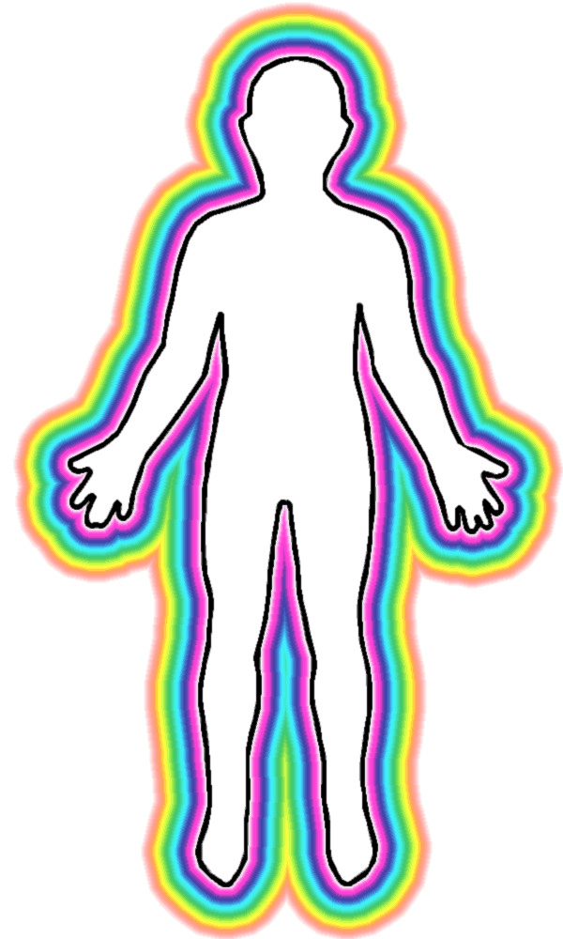

Where attention goes- qi follows. Qi follows consciousness.
The false master may run the program. All problems stem from this state which perpetuates closed-ness. The false master does not treat the body well. Be open to ourselves, to face and work on problems. It takes courage!
Unifying Shen and Shing-ling helps bring understanding to patterns and how to replace them.
Internal joy is a natural state. Bright universe, bright qi, healthy qi
is a natural state.
Shen sees the world as perfect. Shen does not want a prison – it wants to be free!

Love
Acceptance
Embrace all possibility
Always
Something in the universe
Is being manifested

With love- more love grows
Without love- the opposite grows
Wildly and out of control
Love becomes weaker and weaker

-40 degrees
The temperature
of indifference

Indifference
Things are things
Not good nor bad
All things
Ever changing-
This is the law of nature
This is the law of the universe
Every good thing
Has the possibility to turn
Every bad thing
Has the possibility to turn
Nothing
Is absolute
⋆

The heart
Is always
Calling out
For love

Love is
Always
Looking
For home

Big and round
Open and free
⋆

Obstacles of Love

Patterns clash
Unhealthy emotion
Results

Taken over
By the thoughts and feelings
I have done so much for you!
And now, you deny me!
You must respect me!

I want you to change
You want me to change
Ha!
The universe is change

Clash of patterns
Not me- it is you
If it is you- it is me

If it is you- it is me
Here we are
Staring each other down
Starving ourselves
Denying qi
Denying Shen
Denying life
⋆

Big Love

Barbra walks right up to me
And says
You are blocking love
You love the fear of love

There is no reason
You should not have
Abundance in love
And in all things

Barbra I want to manifest
true love,
Big love
This has been my aim

This small love
Is a narrow path
Selective and conditional
With prison bars

Between my head and heart
This divisiveness?

The pox
between my breasts
a reminder
nothing is absolute

It is a broad path
You point to
A bright clear light
A sparkling universe

Barbra you pick my head
Up off the ground
And place it gently
On the shoulders square
You take a moment
Out of your life
To witness mine
And change the course
For both. Forever

Ssssh she says…
Shen knows
Shen believes
Shen manifests

Barbra,
Do you see the line
⋆

Reflections
Looking to be satisfied is an external focus.
When the lower Dantian is full there are no cravings or desires.

Respect
Master
Wears his undershirt
Until it is threadbare
And whole-y
It then becomes a rag
And when the rag
Can dust no more
It is planted in the garden
To become of use again
⋆

Do you love the planet? Respect it!
Lower wants of material things.
Do you love people?
Respect them.
You are responsible for you, I for me.
To respect and love I do not get entangled with the hooks of your patterns or mine.

⋆
Science and technology
Advance to the point of extinction-
Humans
And all other living things
What doesn’t deserve our respect?

Life Cultivation
How do you manifest your life?
What is your imprint?
Be deliberate about the gathering and use of qi.

The qi field is an even playing field. Play. Be. Moment by moment. Trust. Openness. Love. Gratitude. True respect.

What can we take with us in to the next life? How we have treated ourselves, others and the world. How we have been in life cultivation.

⋆
All of life is equally great.
Everything unfolds naturally.

Gratitude

Gratitude
Receiving something beneficial,
born of love
Responding to what has been given
and received

Giving thanks for each and every cell
For the basics given to the body
For this practice
Of honouring Shen

Teaching
Fundamental patterns that block the unification of Shen and Shing-ling:
Taking things for granted. Entitlement. Never enough. Desire. Greed. No fair! Dissatisfaction. Ignoring the chain of good. Self centered. Selfish. Numb. No response. Indifference. Seeking the approval of others. Hiding and avoiding.
The body can contain unhealthy information. This needs to be cleared out and replaced with bright and healthy qi.
Settle problems before you go to sleep. If you cannot, in your mind’s eye put the problem in a bag and put it in the trash can.
⋆

Tai Chi Husband
You, my beautiful husband
(A long ago promise made and broken-)
Are practising Tai Chi on a grassy field
Golden lit with morning sun
So strong- so responsible
Generating light
We have not been married for decades
And here you are in mind’s eye reflection
In gratitude I see you and release you
in love to love for love
⋆

Waking Up

A lot of dust has settled
On the shing-ling and shen
They need awareness
This is so!
Polish in the practice
The semi precious gem
to find
This gem
This day
Is precious
Not partial, not semi
whole

*

Short cuts
Short cuts are just that
Cuts
Quick fixes
Short circuits
Master takes a long time settling in
Anchoring in the qi field
He and others build and tend
One question, one small question
Can take a long time to answer
Minutes turn to hours, hours turn to years

⋆

Practice
Afternoon healing session brings us to the awareness if you think you can do it- you can do it. We play a game of Growing Hand. We work in pairs and imagine qi enlarging the hands and lengthening the fingers. Matching wrist to wrist we see where the hands are prior to and after the exercise.

⋆
Truth
Truth is a totality and no one discipline, or school of knowledge can define or express totality.
Nothing is absolute.
Seeking truth is getting to know ourselves.
Every single thing has law. Here on earth we are governed by abiding natural law.

Who Says?

Who says
If you cultivate your own garden
You cannot fight for justice?
Choose your weapon
Slay the dragon
With a silver sword
Or give of your life
lay down your life
For love. Big love
⋆

Beatrice Heals Part One

Beatrice comes to heal
her eyes
And pull in some energy
Maybe fill up her reserve
A surprising thing happens
As she is bright light unified
Shen and Shing-ling

Days before I have renamed her-
Therese
When I come upon her I say
Bonjour Therese, comment ca va?

She does not correct me, nor does she answer
Therese-
Saint Theresa of Avilla
Saint Teresa of Calcutta

When I catch on I say I am sorry
I don’t know why I renamed you
Its okay she says, its just a name
It is your name Beatrice.
It matters. Do you see now?

Beatrice Heals Part Two

The frozen heart
Thaws
Opens to a world
To an entire universe

Joy
Amazement
Wonder
Reverence

Tears come
When the Self
Touches the self

Crying is cathartic
Crystals
Break down
Particles of
Greed and constraint

This closed fist
Tight and stingy heart
Gives way
In the thaw
To the warm bright clean light

Light
Melts down
The self and selfish heart
To one
One particle
The one that contains
The entire universe!

You enter in
It in turn enters you

The heart is your home
This heart
This home

⋆

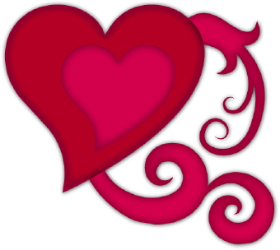

The root of evil
The root of evil is ignorance
What is ignorance?
Evil, is live, with letters backwards
Does ignorance know this?

Ignorance: the absence of knowing

⋆

Wise Woman Pauline Lee
Wired to serve. To heal. To know. To know how to impart treatment. Treatment. Transmission of information. Transmission. Transformation that we all heal. Transformation. Straight up- head to hands, to heart. The veil lifts and we are back in time. Or are we far ahead? It matters not. The moment is perfect. There is nothing you do not know for you know the one who knows. You play on the qi field. You access the vast information on the qi field. Pauline Lee. Wise woman Pauline Lee.

⋆

A man kicks a dog
You react quickly
And pick the dog up
The dog bites you
⋆
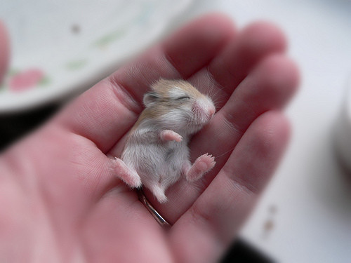

The State of War

A baby mouse*-
Soft pink bundle of nerve and mite
Scurries
Across the floor
In this room of
High attainment and bright light

Catch it!
Stomp on it!
Sweep it away!

Or behold this wonder of creation
In contemplation

How may we live
In harmony
As one?

Justice is harmony. With each other. And nature.

To the Table
A bare table
In an empty room
Slice of light from a
A crescent moon
Falls and forms patterns
On a solid wood surface

The room is silent
The table waits

A door slowly opens
Trust shows up
And sits at the head
Slight curve to back
Feet planted
Open and ready to
engage

To review this day
Trust calls out
What has been done
To be of benefit
To self and to others?

Is there something to settle?
Then settle
Tomorrow
The light of the moon
Will cast a different shadow
⋆

Focus
When a pattern is triggered, do not hesitate to transform it. Be comprehensive, fair and objective.

At the Table
Serve the warm dish first
Positive characters add
the flavour of life
Don’t overgrow, or over emphasize
Or under appreciate
Self confidence
Self recognition
Self respect- these will be your main ingredients
Can you sense the things you need to work on?
Have you changed unhealthy habits?
Is your awareness deepened?
Do you have realization?
Are you relating to others better,
at the table?
⋆

Melissa’s Laugh
Melissa’s laugh
Is a babbling brook
Clean clear sparkling
From the innermost
Wellspring of the void
⋆

How to Heal

We had a sense of direction
And then we got lost
So far from home

The guides came
And joined us hand in hand
To take a simple walk, they said

Access this vehicle- yours
These eyes, this mouth
These hands, this universe

Every moment is healing time
In the Shing-ling garden
Do your work then rest
⋆

Awareness
When the heart is open, you hear beyond what is being said. This is a special ability.
When safety needs have been met, trust with an open heart.
Trust the qi field. Trust the bright healthy qi of the universe. Open to each moment with utmost reverence.

Universal Law of Completion- for Falcon

A boy takes a rope
And tries to fly
Across a shallow river
As he sees others doing so
He falls- he does not fly
The rope chaffs his palms to raw
The sharp edged rocks
In the shallow river
Cut and bruise his body

His father says with force
To teach you a lesson
You must get up
And walk back to the hut

A monk, standing on a hill
Looks down and sees the boy
Broken with drowning tears
He lifts the boy
In to his arms
And carries him to the hut

Many summers pass
The boy, now a man
Asks the river
Why did my father choose this?
The river calm and clear
Answers back
He chose this
Because the Monk did not
⋆

Age with Grace

For as long as I may tend
This garden, this beating heart
May I serve
With reverence, openness and love
May I be present unto growth
And when that
Is no longer of purpose
May my body become
Like a piece of the master’s dusting rag
Used up. Returned.

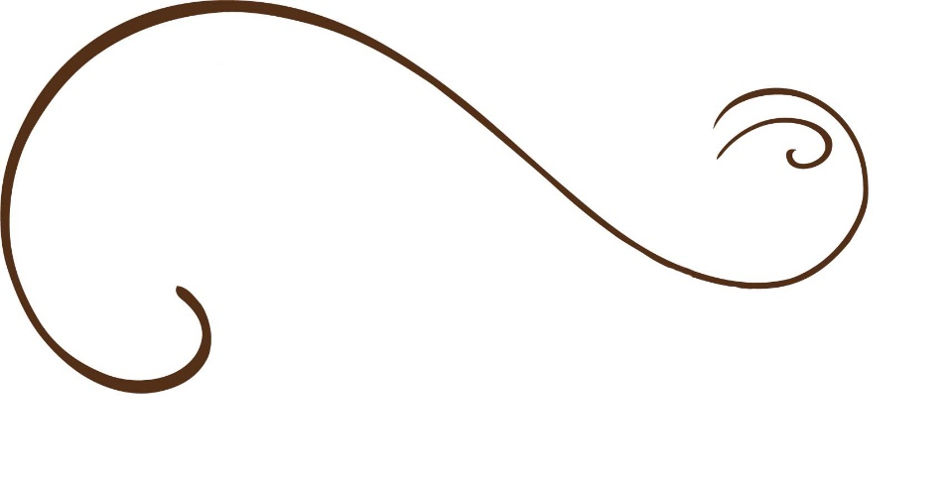

And my Shen, may it spiral and retreat into the kind
and benevolent light

⋆

*Stacey Couch on mouse: | May 24, 2018, 7:19 PM
The universe is conspiring to shower you with tiny, quiet miracles every single moment of your life. Mouse spirit animal knows this. This is what makes mouse a monk. If only we all could know this. Mouse in his quiet, unassuming way prompts us to remember that miracles make sense in the quiet where nothing else clouds our thoughts. Miracles make sense when living a tiny life in a tiny universe. Mouse knows this. This is what makes mouse a monk. If only we all could know this. When we stop looking far and wide and outside of ourselves for the answers and, instead, truly focus on what is right here with us, we begin to see the Divine in the details.
One last message from mouse spirit animal – remember the mystical law that “what is small is really big”

